

WORK ORDER with BARCODE

User Manual for additional features added
Version 5
03/18/2025

Table of Contents
1. Introduction 3
1.1 Overview 3
2. Getting Started 4
2.1 Cautions & Warnings 4
2.2 Set-up Considerations 4
2.3 Accessing the System 4
2.4 System Organization & Navigation 5
2.5 Exiting the System 5
3. Using the System 6
3.1 Choosing Module 6
3.2 Encoding or Adding Check 6
3.2.1 Selecting a customer 6
3.2.2 Selecting an Account Number 7
3.2.3 Encoding with Attachments 7
3.2.4 Selecting an Invoice Number or Reference Number 8
4. Troubleshooting & Support 9
4.1 Error Messages 10
4.1.1 Applied Amount is greater than the Check Amount 10
4.1.2 Check amount should be greater than zero (0) 10
4.1.3 Check Due Date should be greater than the current date 10
4.1.4 Check Due Date should be equal or lesser than the current date 10
4.1.5 Entered amount exceeds the available amount. Please enter a valid amount. 11
4.2 Support 11

Introduction
The development and implementation of an enhanced Work Order Management System integrated with barcode scanning functionality. The system is designed to streamline the process of creating, managing, and finalizing work orders by incorporating barcode scanning for efficient item retrieval and tracking. This documentation provides a comprehensive guide for users to effectively utilize the updated Work Order with Barcode add-in, focusing specifically on the barcode scanning feature.

Overview
The Work Order Management System allows businesses to efficiently save and retrieve work orders, ensuring seamless tracking and management of tasks from initiation to completion. Work orders can be updated throughout the job's lifecycle, enabling businesses to monitor progress, adjust details as needed, and ensure that all services are performed according to client specifications. Upon completion of the assigned work, the system facilitates finalizing the work order and processing any remaining payments through an integrated Point of Sale (POS) system.
The integration of barcode scanning within the system adds a layer of efficiency by simplifying item lookup and management. Using a barcode scanner, users can quickly search for items related to the work order, reducing the time spent on manual data entry and minimizing the risk of human error. This feature is particularly beneficial in environments where inventory management and item accuracy are crucial to operational success.

1.2 Significance of the Barcode Scanner Integration
The inclusion of barcode scanning technology addresses several key operational challenges:
- Efficiency: Barcode scanning reduces the time required to search for and input item information manually, streamlining the workflow.
- Accuracy: By minimizing the need for manual data entry, the risk of errors in item selection or data input is significantly reduced.
- Improved Inventory Management: Businesses can more easily manage their inventory, ensuring that items related to specific work orders are accurately tracked and accounted for.
- Real-Time Updates: The system allows users to instantly retrieve information related to any scanned item, providing up-to-date data that supports decision-making and work order adjustments.
This explores the functionality and usability of the updated Work Order with Barcode add-in, examining the impact of barcode scanning on operational efficiency and user experience. Through the system's development, key design considerations and technical challenges are addressed, leading to a solution that enhances the overall management of work orders in a business setting.

Getting Started
The development and implementation of an enhanced Work Order Management System integrated with barcode scanning functionality. The system is designed to streamline the process of creating, managing, and finalizing work orders by incorporating barcode scanning for efficient item retrieval and tracking. This documentation provides a comprehensive guide for users to effectively utilize the updated Work Order with Barcode add-in, focusing specifically on the barcode scanning feature.

Cautions & Warnings
Ensures that you selected the correct database before start using the Work Order.

Set-up Considerations
Ensure that the Work Order is setup and configure correctly to avoid conflicts and errors, if none, please contact any of the SPU Team Programmer.

Accessing the System
To access the add-ins, first login to RMS Manager > Utilities Tab > Add-Ins > Work Order Entry V.5.exe.
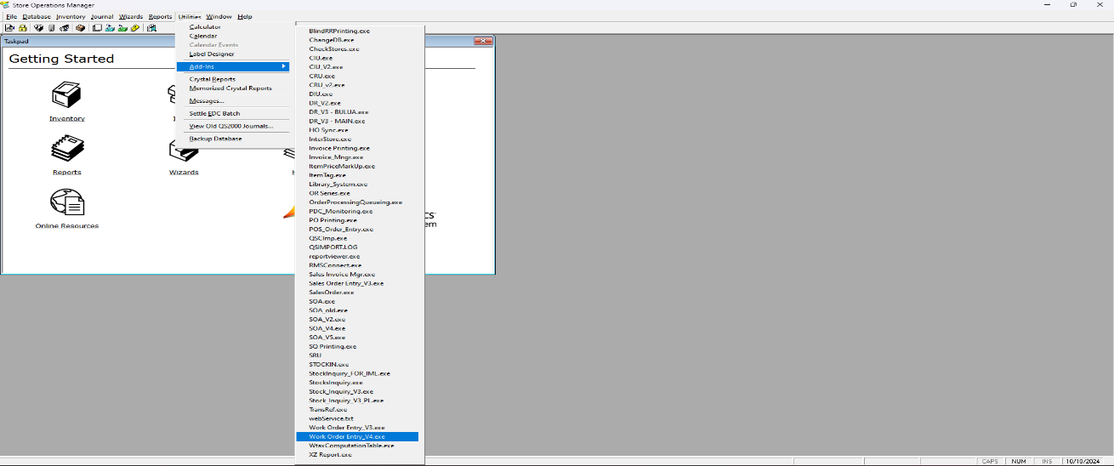
Figure 2.3.1 Work Order Entry

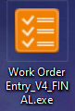
Figure 2.3.2 Work Order Entry – an icon for shortcut in the desktop

System Organization & Navigation
The following are the parts of the newly updated Work Order Entry under the version 5.

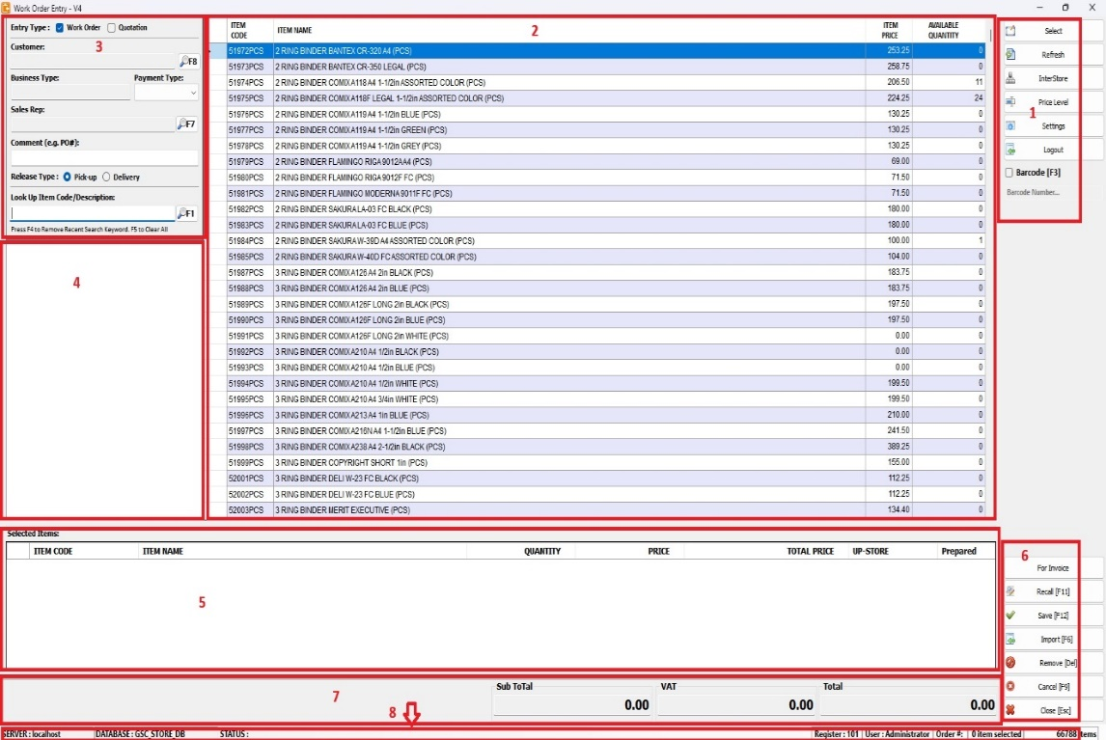
Figure 2.4.1 Work Order Entry – environment

1. Side buttons – consists of functional buttons.
2. Grid table – this is a tabular form who’s responsible for viewing of items
3. Side Navigation Bar – this where you select Work Order or Quotation, selecting Customer, Sales Representative, Business Type, Comment, Release Type, and Searching for Items.
4. Tree View – responsible for searching.
5. Grid table – this is a tabular form who’s responsible for viewing of items that was selected.
6. Lower Side buttons – consists of functional buttons for grid table selected items.
7. Views for total, subtotal and Vat
8. Footer – this consists important information of the server’s name and the chosen database. This will also help the user to ensure that it navigating or using the correct database.

Exiting the System
Navigate the Side Navigation bar and click “Close” button. It will automatically close or exit the application.

Figure 2.5.1 Exit button

Using the System
The development and implementation of an enhanced Work Order Management System integrated with barcode scanning functionality. The system is designed to streamline the process of creating, managing, and finalizing work orders by incorporating barcode scanning for efficient item retrieval and tracking. This documentation provides a comprehensive guide for users to effectively utilize the updated Work Order with Barcode add-in, focusing specifically on the barcode scanning feature.

Choosing Order type
To navigate and select the type of order, you can choose either "Quotation" if the customer only wants to check prices or perform canvassing, or "Work Order" if the order is to be processed through the POS.

Figure 3.1.1 Work Order Entry – to choose either Quotation or Work Order
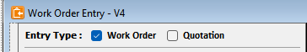

Selecting a customer
This allows the user to choose the customer.

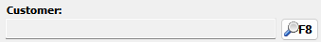
Figure 3.2.1 Selecting customer

- By clicking the F8 button or a F8 keys.
- After clicking the F8 button, it will pop up a form in the screen for the user to choose the customer.
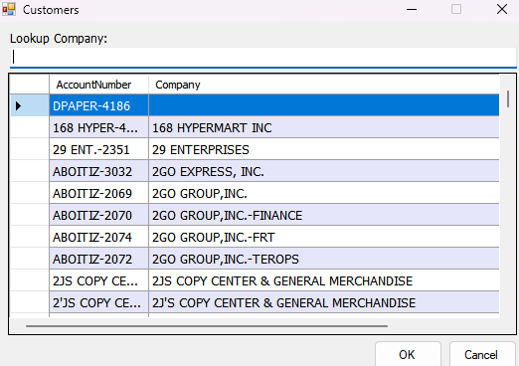
Figure 3.2.2 Selecting customer – a view for customer list’s

- After choosing and select the customer the Customer’s Company Name will display to Customer field.

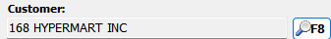
Figure 3.2.3 Selecting customer – will display to customer field

Business Type
This is automatically fill in after choosing the customer.

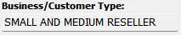
Figure 3.3.1 Selecting Business type

Payment Type
This allows the user to select payment type.

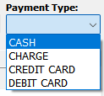
Figure 3.4.1 Selecting payment type

Selecting a Sales Representative
This allows the user to choose the Sales Representative.

Figure 3.5.1 Selecting payment type
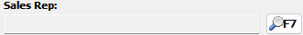
- By clicking the F7 button or a F7 keys.
- After clicking the F7 button, it will pop up a form in the screen for the user to choose the Sales Representative.
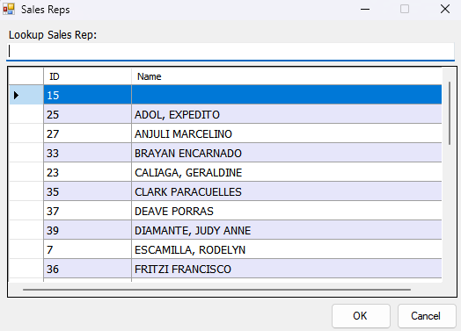
Figure 3.5.2 Selecting Sales Representative

3. After choosing and select the Sales Representative the Sales Representative Name will display to Sales Representative field.

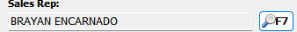
Figure 3.7 Selecting Sales Representative – will display to Sales Representative field

3.6 Comment field
This allows the user to input Comment.
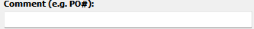
Figure 3.8 Comment field

3.7 Choosing the Release Type
This allows the user to select the release type whether Pick-up or Delivery
Figure 3.9 Release Type

3.8 Searching for Items
This allows the user to search an item/s by Item Code or Item Description
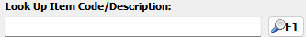
Figure 3.10 Searching for Item/s

- Start typing in the Searching field.
- By clicking the F1 button or a F1 keys.
- After clicking the F1 button, all your searching will be placed below.

Figure 3.11 Searching for Item/s
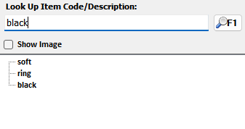

- Then the table for item view will be filtered based on the Searching field.
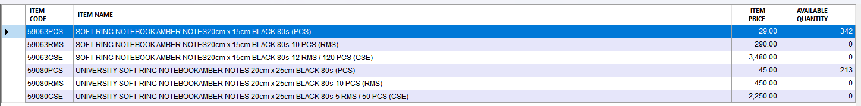
Figure 3.12 Table to view the search items.

3.9 Searching for Item Prices
This allows the user to view the item prices: Retail, Wholesale, D1 and D2.
- Just double click the content of Table view for the search items. Please see Figure 3.12.
- After clicking the content then it will pop-up another form from pricing
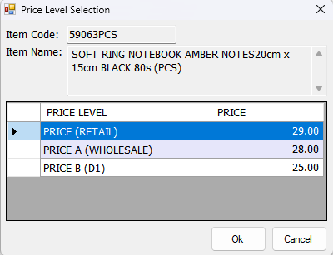
Figure 3.13 a view for item pricing.

3.10 Work Order
This allows the user to finalized his order before proceed to POS.
  - If you click button OK from view pricing. Please see Figure 3.13.
  - After clicking the button OK, then the selected item will display from table view for Work order.
Figure 3.14 – Work order with single item.
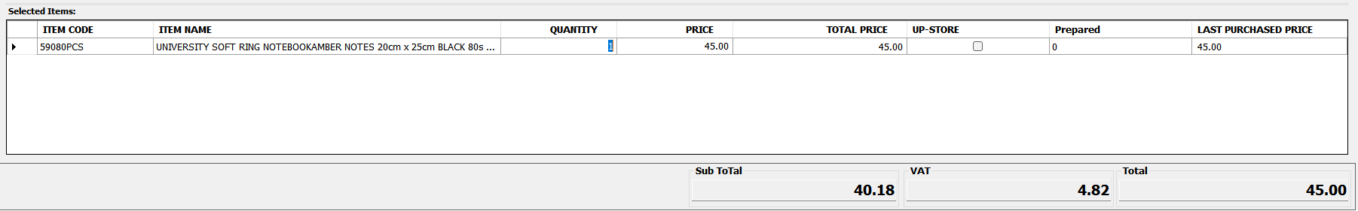

  - Then input the Quantity.
Figure 3.15 Quantity from work order table.
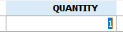

  - If you want to add other items then just repeat the process from Figure 3.12 if the same item, if not the same item, then proceed to Figure 3.10

Figure 3.16 Work Order with multiple items
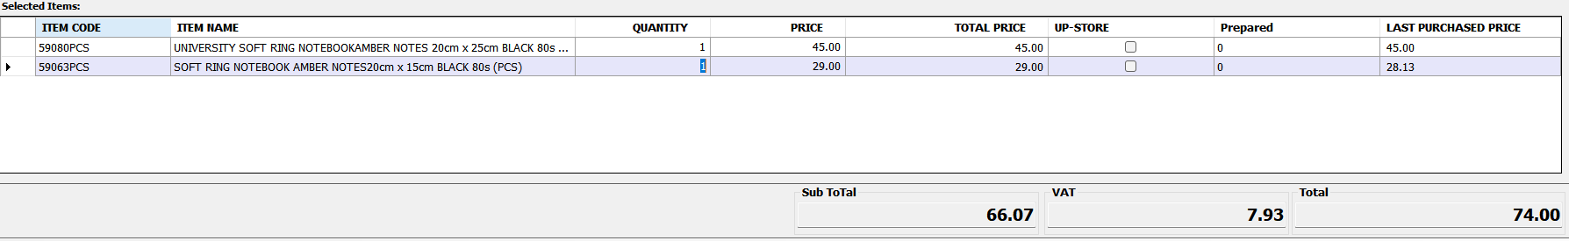

  - If you want to save this Work Order, just click the button save of press F12

Figure 3.17


  - After pressing the F12, then will pop-up message with an option Yes or No, if you Click No, will go back to Figure 3.16, if you Click Yes then will proceed to processing.

Figure 3.18
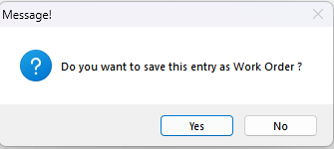

  - Then will pop-up a Success message, then click ok to proceed.

Figure 3.19
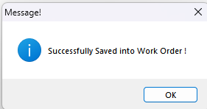

  - Then, a Work Order Number will pop up for reference to the POS.
Figure 3.20
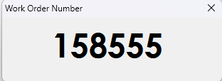

ss

Troubleshooting & Support

Error Messages

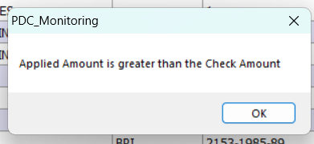
Applied Amount is greater than the Check Amount

Ensure that the Applied Amount is equal or lesser than the Check Amount.

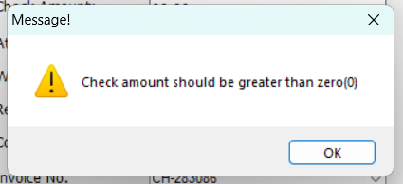
Check amount should be greater than zero (0)

Ensure that the Check amount field has a data or amount.

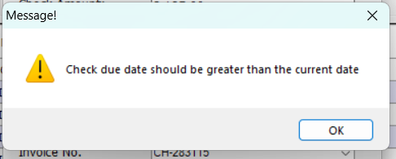
Check Due Date should be greater than the current date

This error occurs on post-dated where we set the check date yesterday or lesser than the current date. To fix, ensure that you put the check date to current or greater than the current date.

Check Due Date should be equal or lesser than the current date
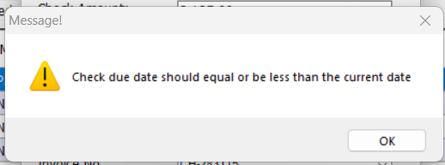
This error occurs on on-dated check where we set the check date is ahead on the current date.

Entered amount exceeds the available amount. Please enter a valid amount.

This error occurs when the applied amount is greater than the available amount. Double check the applied amount or available amount to solve this problem.
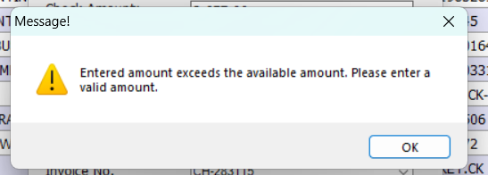

Support
If other errors occur that is not mentioned in this manual. Please contact the SPU to resolve the issues or concerns.

Table 1 - Support Points of Contact
Contact | Organization | Phone | Email | Role
Jan Rey Dondoyado | SPU |  | systemdeveloper@starbright.com.ph | System Developer
Mark Angelo Aniscal | SPU | +639072086406 | systemdeveloper@starbright.com.ph | System Developer
sNeil Mark A. Luspo | SPU | +639638383715 | systemdeveloper@starbright.com.ph | System Developer

